**Segment geometry (Seg geo)**

Base version:

This is the version for the optimization process, in case of magnet flux barrier is divided into two portion:

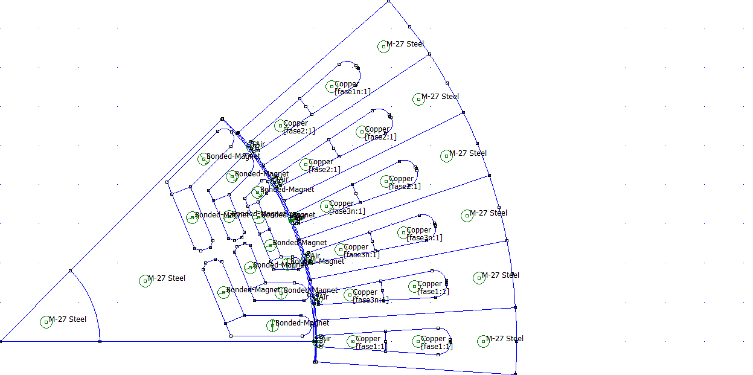

Deluxe version:

By the use of the two parameters present in data0, reported below, is possible to add circular junction to barrier side and move the barrier towards the shaft like in a IPM flux concentration machine:

data0 value normally set

**geo.RaccBarrier='OFF';**

**geo.DTrasl=0;**

data0 value set for deluxe version

**geo.RaccBarrier='ON';**

**geo.DTrasl=-5; (must be a negative value)**

